Session 1: Assignments

1. Answer following questions

* **How to check a variable’s type?**
* You can use function called **type** in python to check variable’s type

Here is examples:

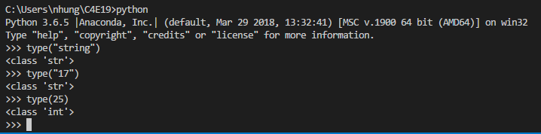

* **In what cases, you will get *SyntaxError* from the compiler telling you that some of your variables have invalid names? Can you give 3 different examples of invalid names?**
* Illegal start ( example start with number )
* Illegal character (example variable’s name contain special character like $)
* The name of varibale matches the keyword in python

Here is examples

1. >>88name = “Nhung”

SyntaxError: invalid syntax

1. >>na$me = “Nhung”

SyntaxError: invalid syntax

1. >>return = “True”

SyntaxError: invalid syntax